Vivekanand Education Society’s Institute of Technology, Chembur, Mumbai,
Department of Technology,
Year: 2024-2025(ODD SEM)

Advance DevOps Practical Examination

Name: Karan Mishra Div: D15B
Roll No: 36 Date of exam: 24/10/2024

Case Study <16>:

Aim: The objective is to develop a solution that automates the resizing of images upon upload to an Amazon S3 bucket. This is accomplished by using AWS Lambda, which triggers automatically when an image is uploaded, resizes it, and saves the modified image in a separate S3 bucket.
Theory: Amazon S3 (Simple Storage Service)
Amazon S3 is a cloud storage service designed to store and retrieve large amounts of data. It organises data into buckets and objects, offering high durability, scalability, and accessibility for various types of content, including backups, media, and logs.

AWS Lambda
AWS Lambda is a serverless computing service that automatically executes code in response to events. It eliminates the need for provisioning or managing servers. You pay only for the compute time consumed, making it ideal for real-time data processing and event-driven applications.

IAM (Identity and Access Management)
IAM allows you to manage access to AWS services and resources securely. It lets you create users, groups, and roles, assign permissions, and enforce security policies to control who can access AWS resources and what they can do with them.
Step-by-Step Implementation:
1.) Creating S3 Buckets:-
1.)Sign into AWS Management Console
2.)Search S3 Service or access it from the Console itself
3.)Click on Create Bucket
4.)Give a name to the bucket. This is the bucket which will contain the original image
which has not been resized by our Lambda function.Here I have given the name karan-original-image.
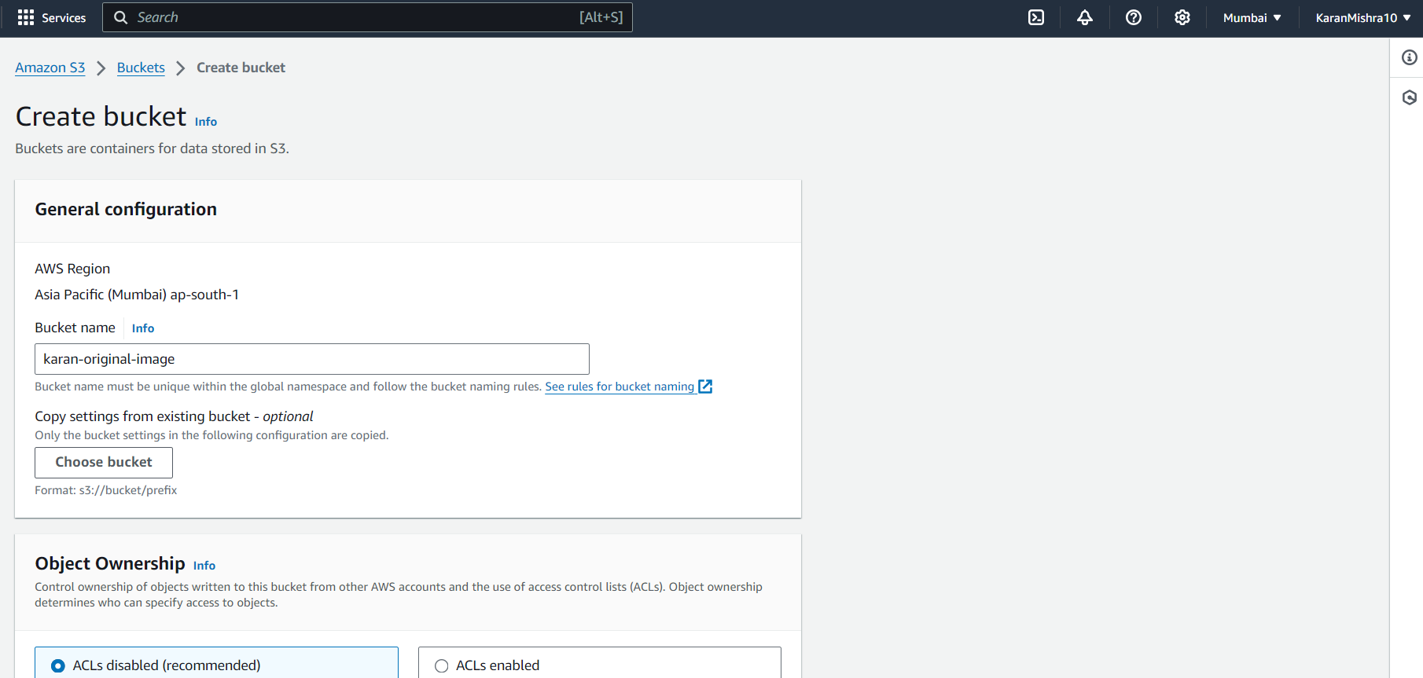
5.)Keep the default Configurations.
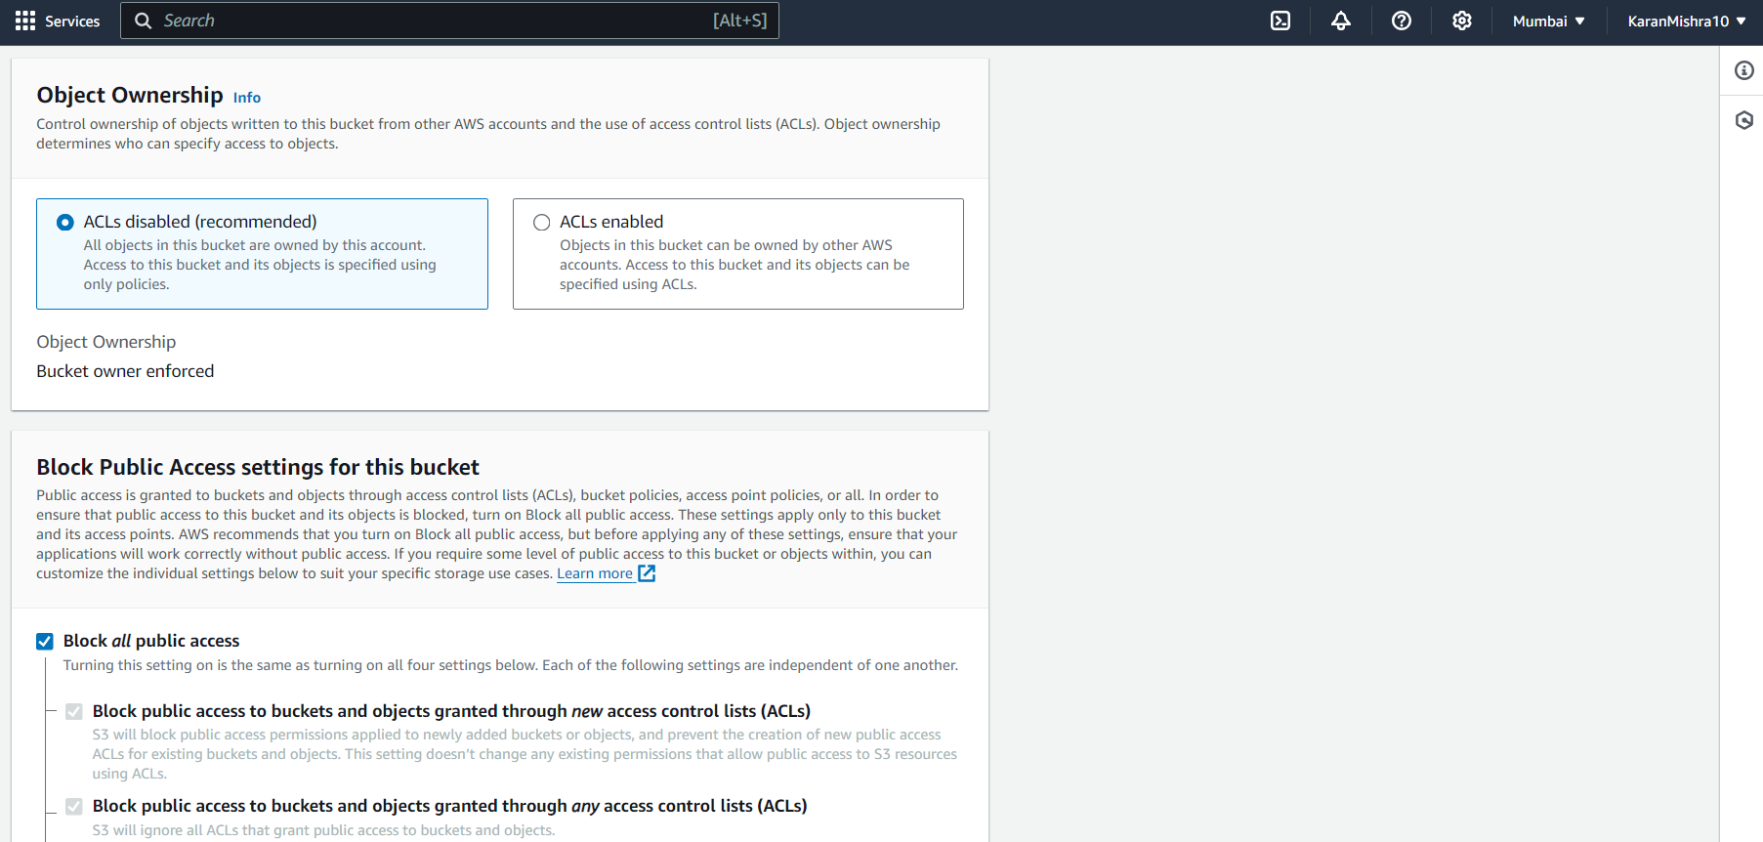
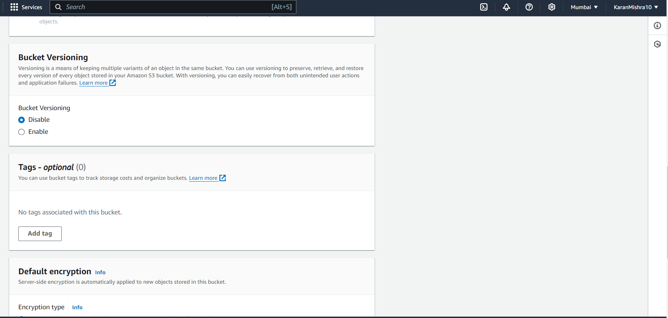
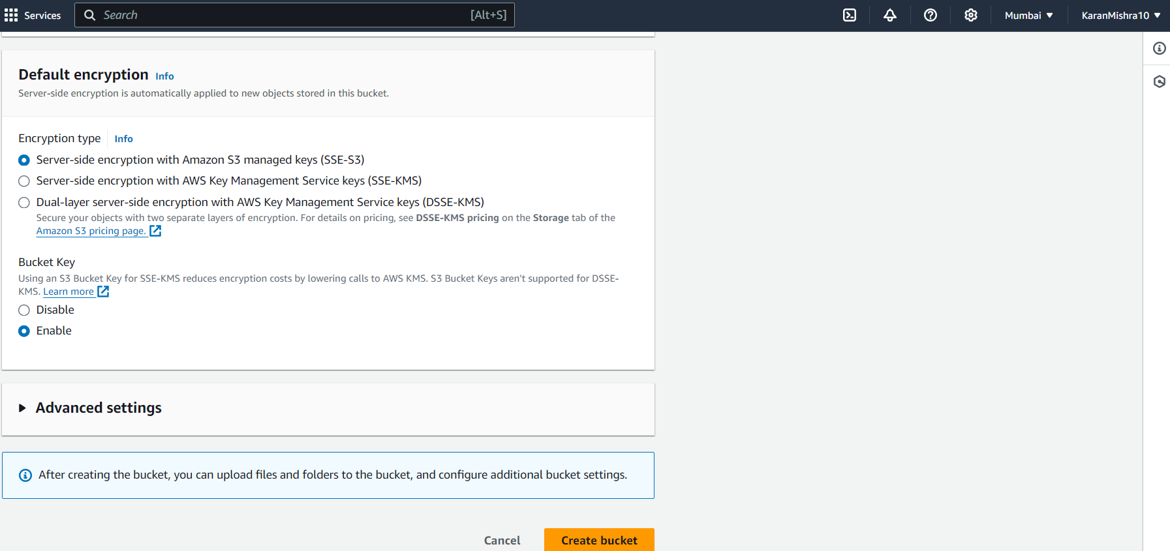
6.)Click on ‘Create Bucket’ to finalise and create the original image bucket.
7.)Repeat the same procedure to create a bucket to store the resized image.Here I have given the bucket name karan-resize-image.
8.)Now both the buckets have been created.
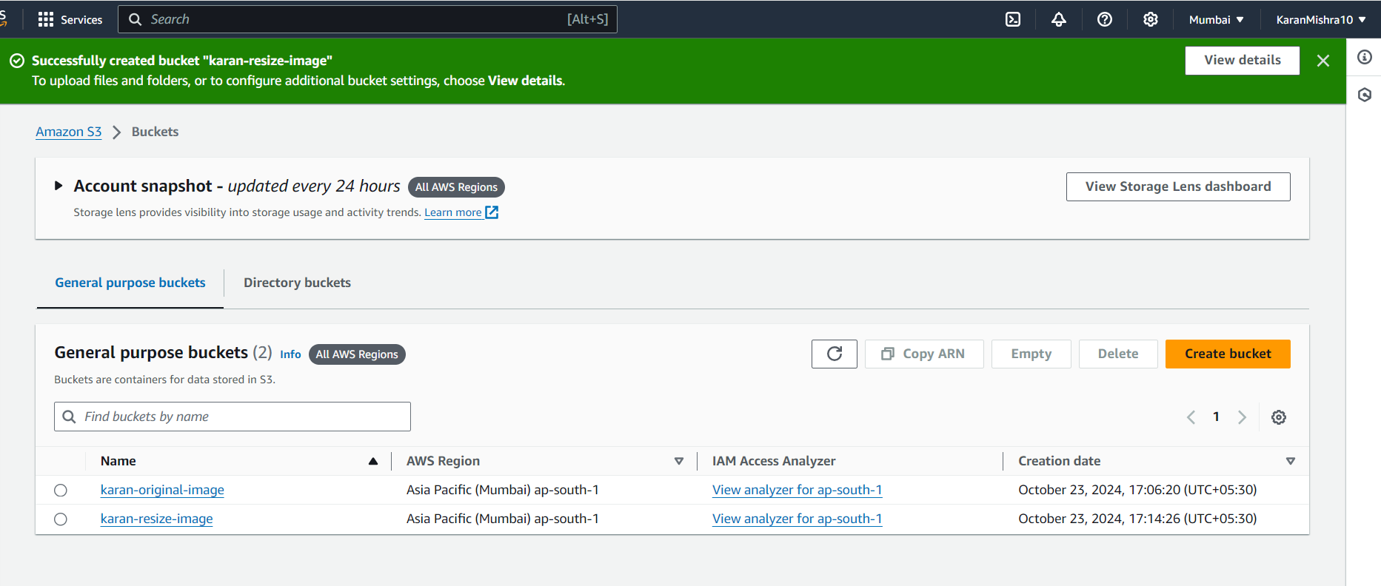

2.)Upload Image to original image bucket:-
1.)Select your original image bucket.
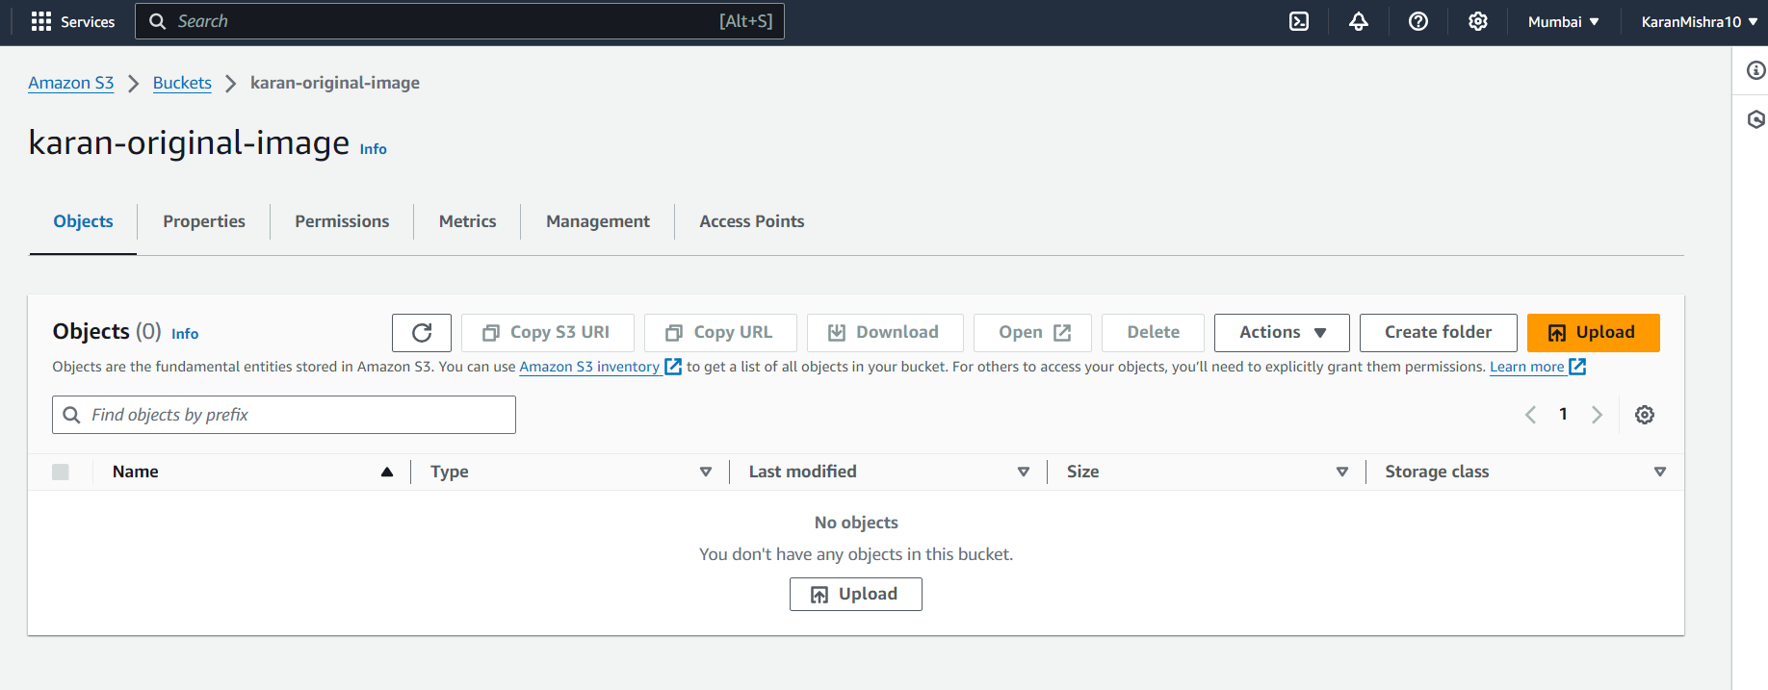
2.)Select the Upload option and Drag and Drop the image which you want to use for the test case of our code.Here I have uploaded an image named axolotl.jpg.
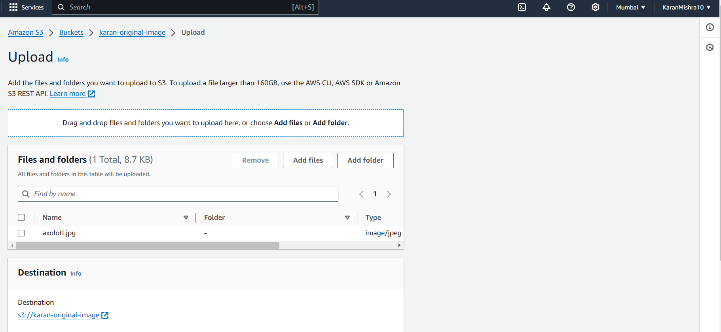
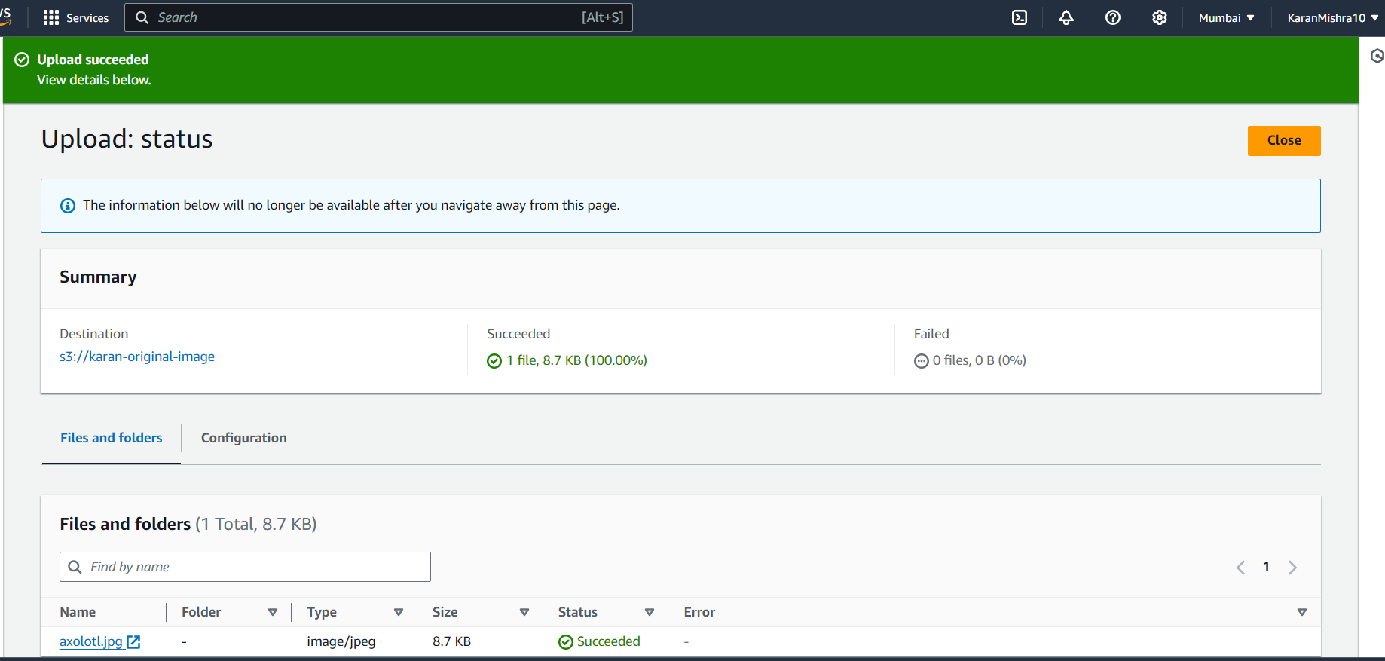
3.)The image has been uploaded to the original image bucket.
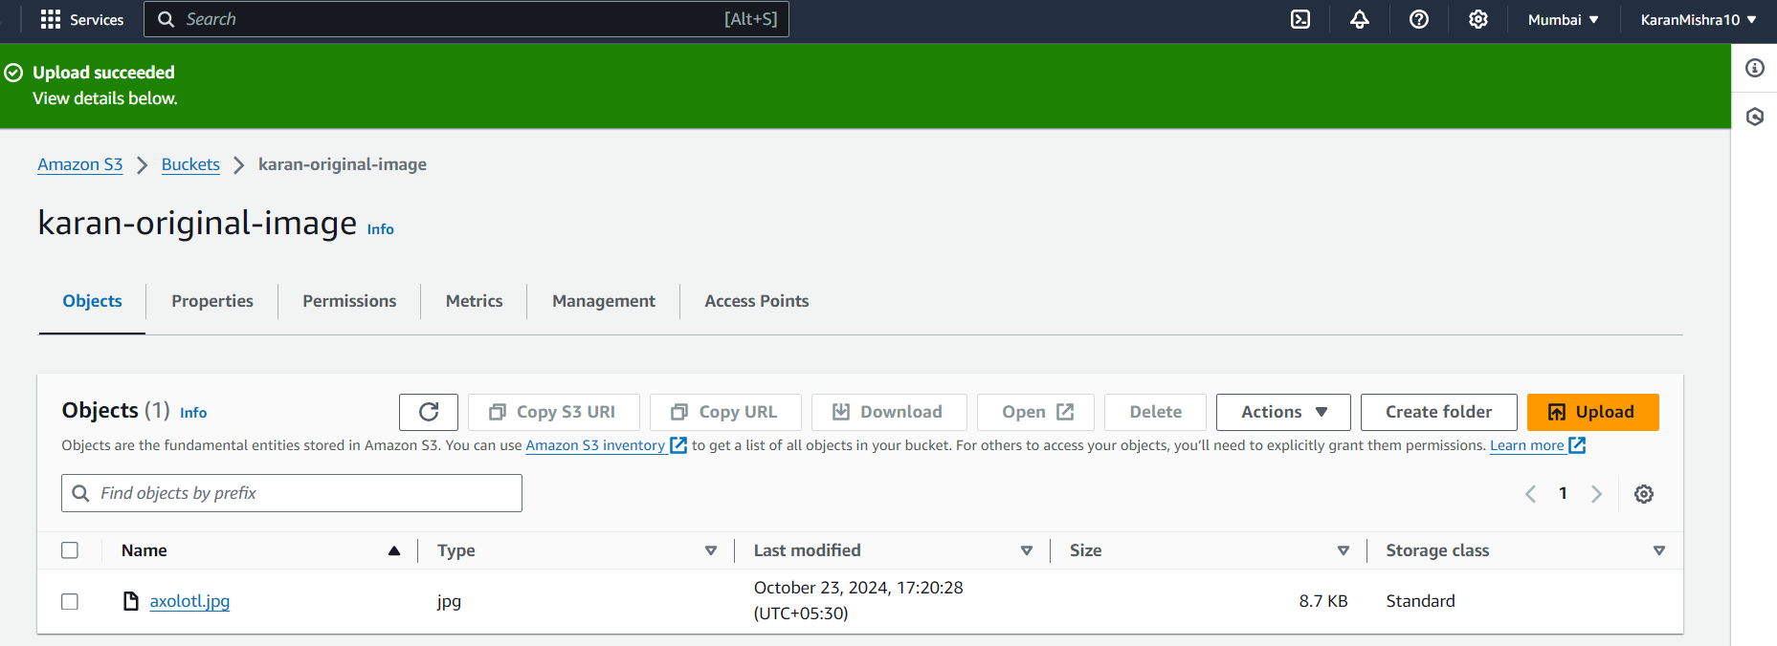
4.)Select the image and click Open option to view the Image in Browser.
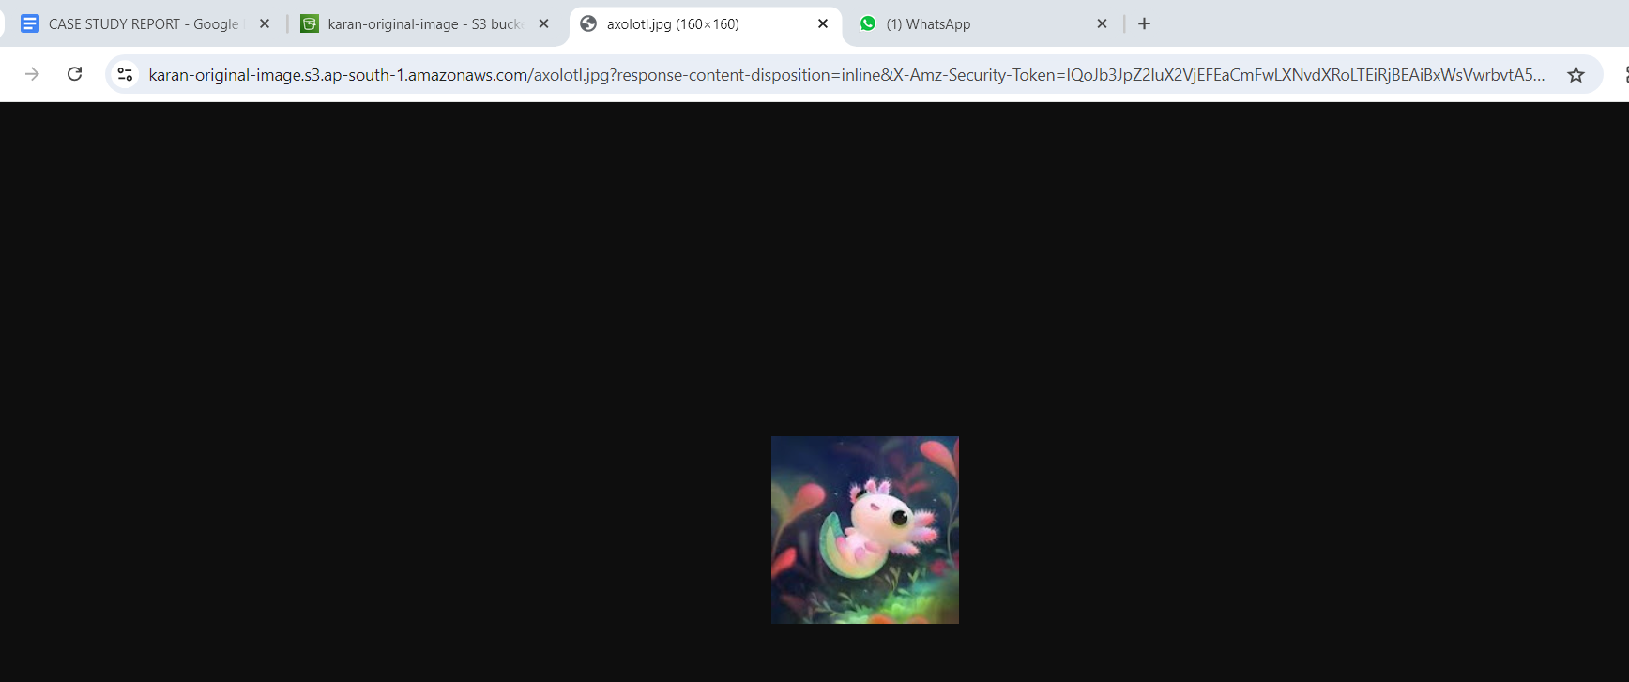

5.)The dimensions of the image in the original image bucket(160 X 160 Here).
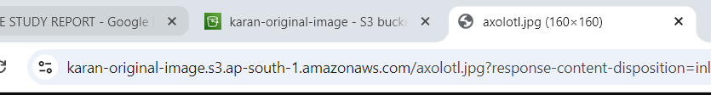
3.)Creating IAM Role for Lambda function:-
1.)Go to the IAM Console from the AWS Management Console.
2.)Select ‘Create a new Role’ and select Use Case as Lambda.
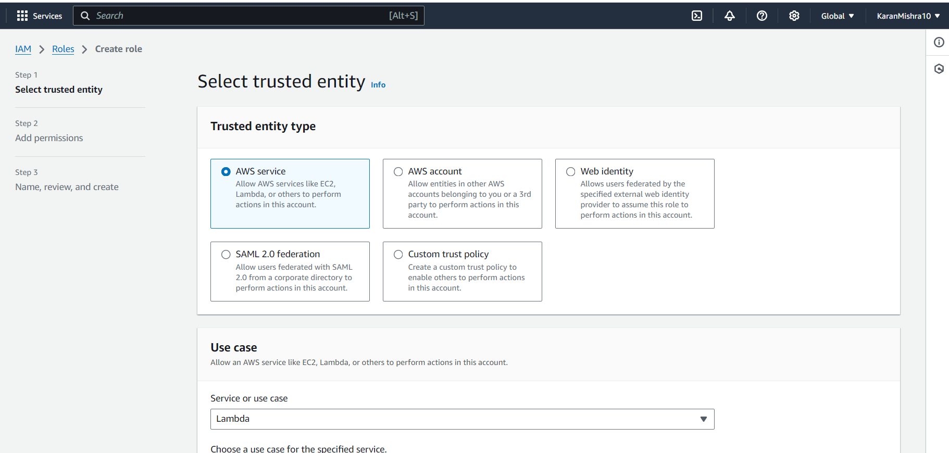
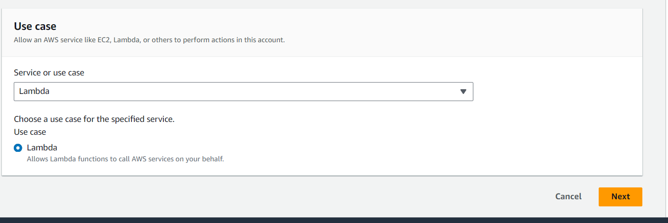

3.)Give a name to Your role and create a role without attaching any policies for now.
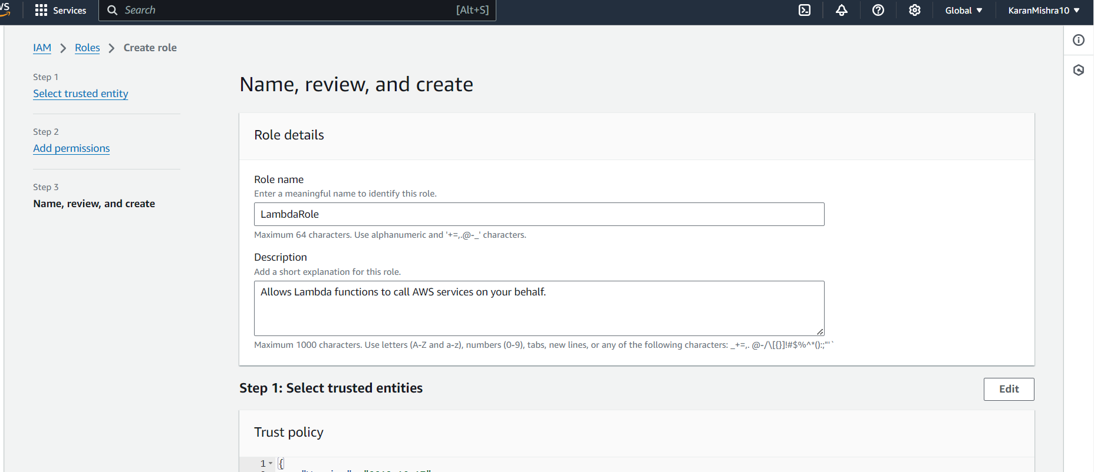
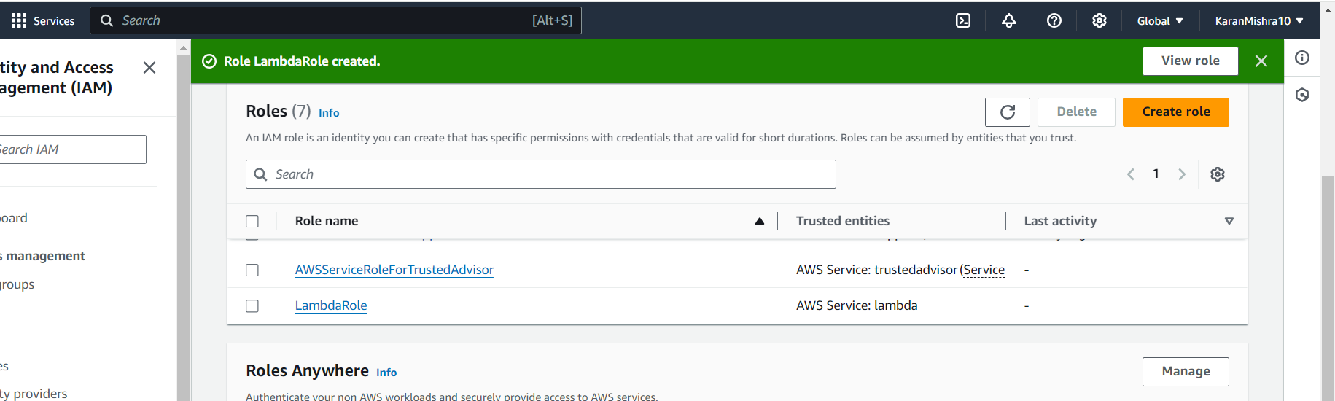
4.)Select the role created . Here I had created the role ‘Lambda Role’.
5.)Scroll Down to view Permissions.
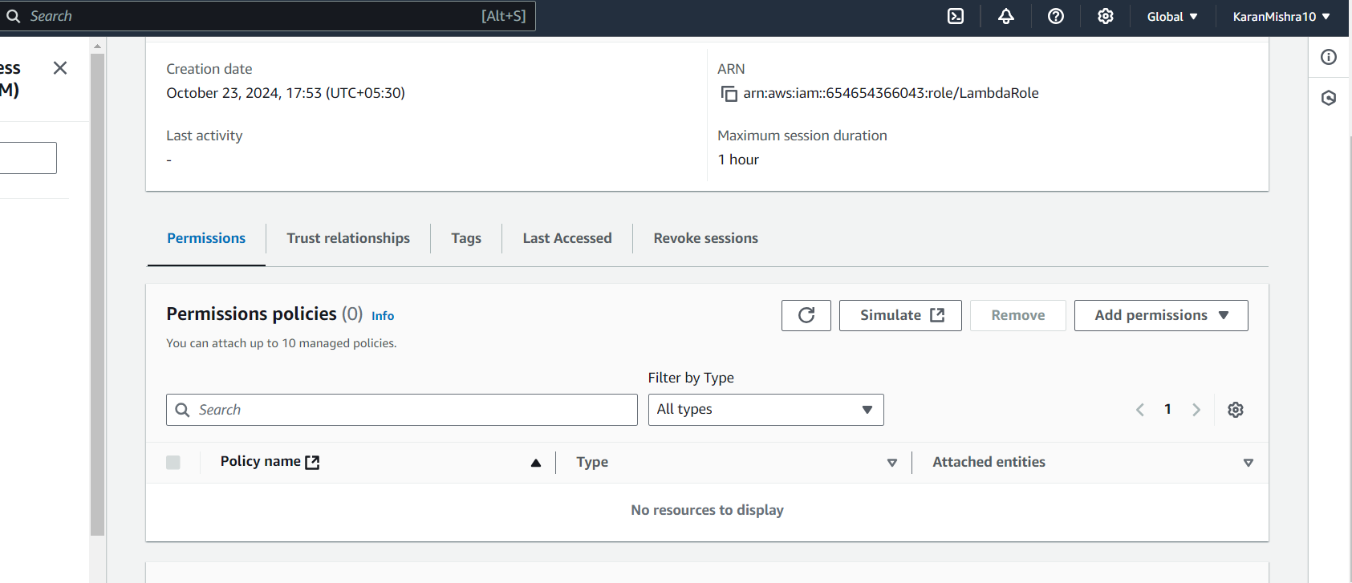

6.)Click on Add permissions and Select ‘Create a Inline Policy’ Option. On the create policy window select JSON Option and replace the default JSON with this policy:-
{
"Version": "2012-10-17",
"Statement": [
{
"Effect": "Allow",
"Action": [
"logs:PutLogEvents",
"logs:CreateLogGroup",
"logs:CreateLogStream"
],
"Resource": "arn:aws:logs:*:*:*"
},
{
"Effect": "Allow",
"Action": ["s3:GetObject"],
"Resource": "arn:aws:s3:::BUCKET_NAME/*"
},
{
"Effect": "Allow",
"Action": ["s3:PutObject"],
"Resource": "arn:aws:s3:::DEST_BUCKET/*"
}
]
}
Here BUCKET_NAME = souce bucket(karan-original-image)
DEST_BUCKET = destination bucket(karan-resize-image)
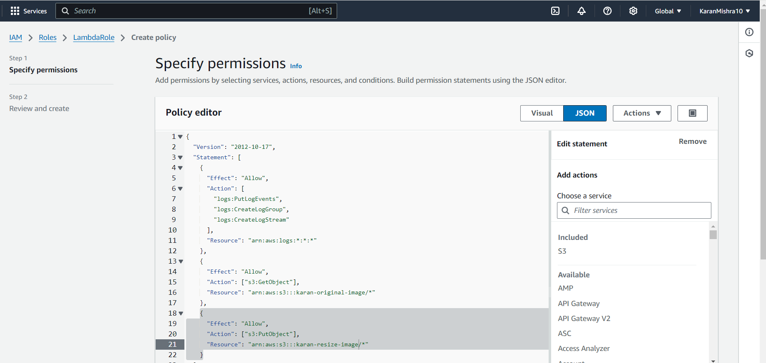

7.)Give the policy a name and click on create policy.After doing this the policy will automatically be attached to your IAM Role.Here I had given the policy name casestudy and it had automatically attached to LambdaRole on creation.
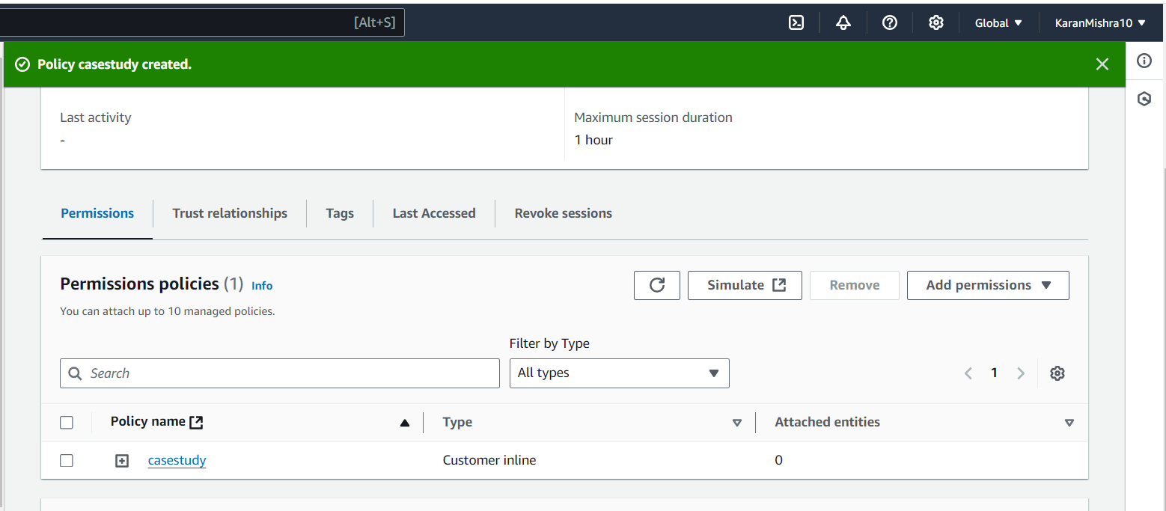

4.)Creating a Lambda Function for resizing:-
1.)Select ‘Create Function’ Option.
2.)Give a name to your Function and select a Runtime Environment. Here I have given the function name ‘image-resizer’ and selected the Runtime Environment as Node.js 18.x.
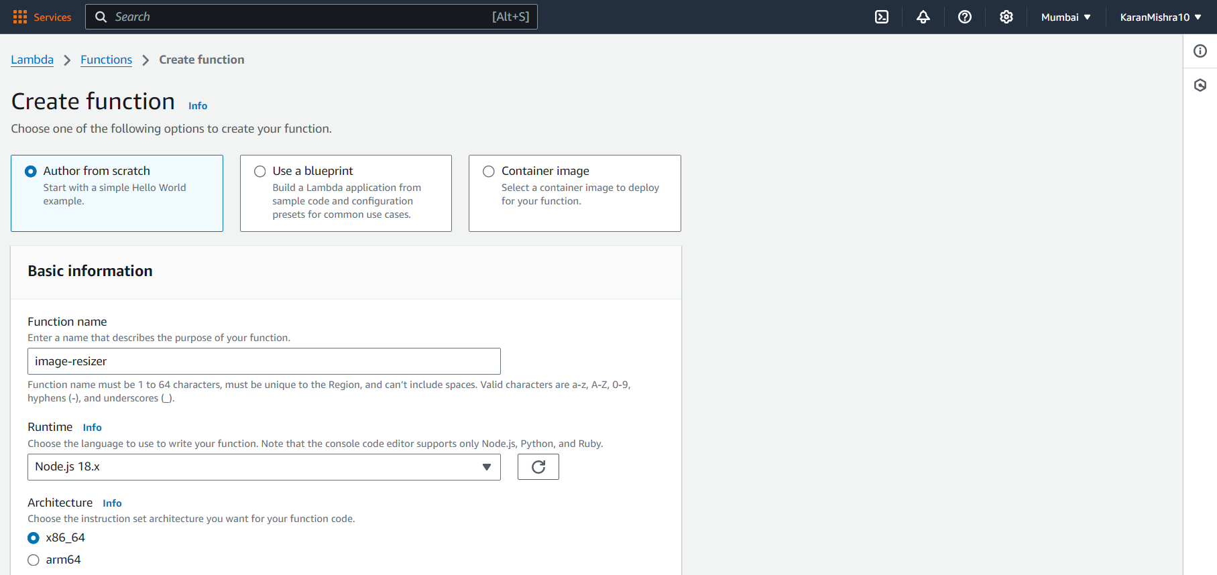
3.)Now Click on ‘Change Default Execution Role’ in Basic Information below Permissions and Select ‘Use an existing Role’ Option and select the role created in Step 3.
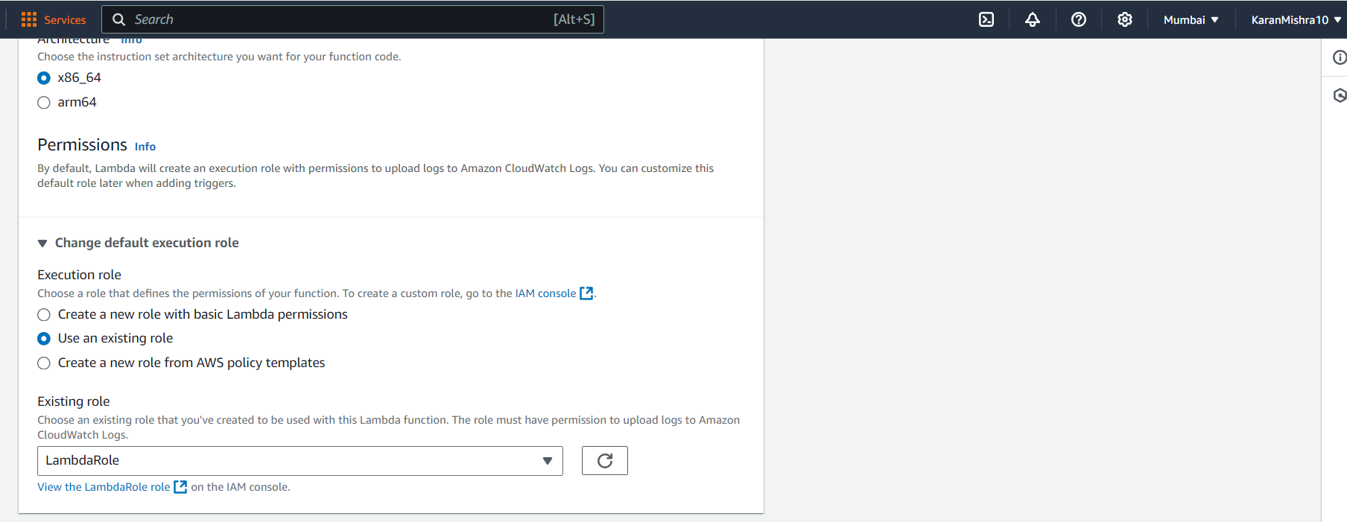
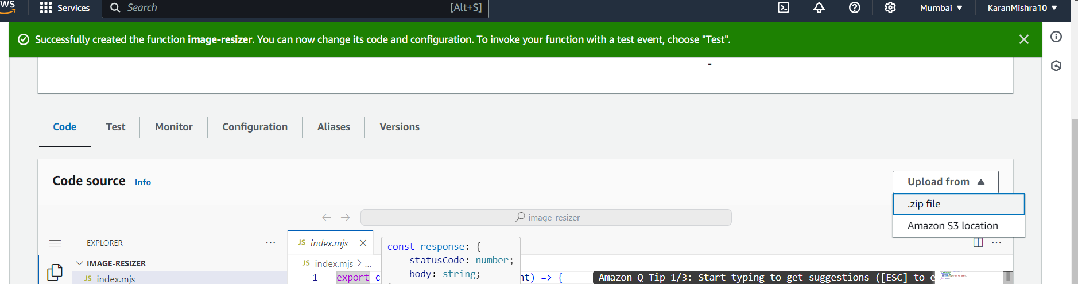
4.)Now after the function has been created select upload from Option in the Code Section of the created Lambda Function. Here image-resizer. Select .zip file option.
To download the Zip file follow this link:-
https://github.com/nikitadev-yt/image-resizer-lambda
And download function.zip from the above repository.It has all the dependencies included to function properly.
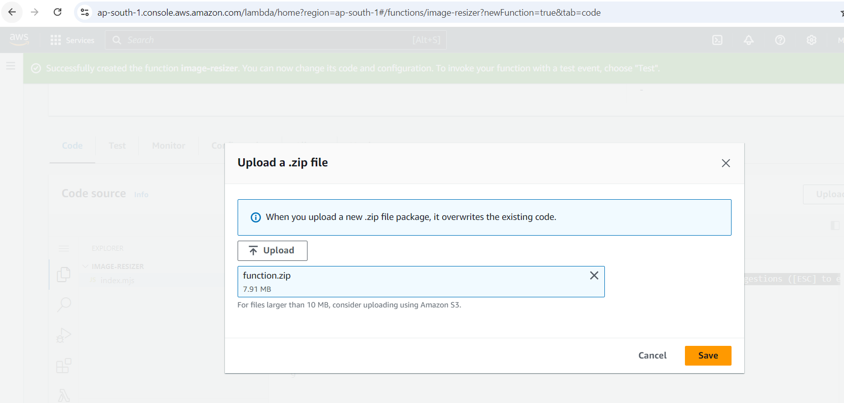
5.)Now go to the Configurations Section of the function and select the ‘Environment variables’ option and Edit . Add the variable as shown
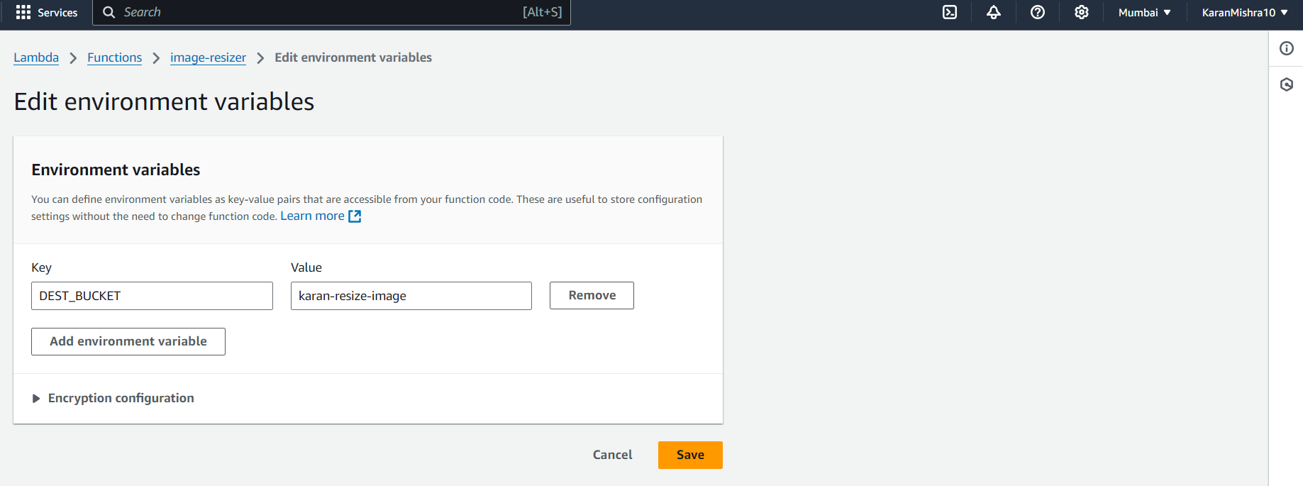
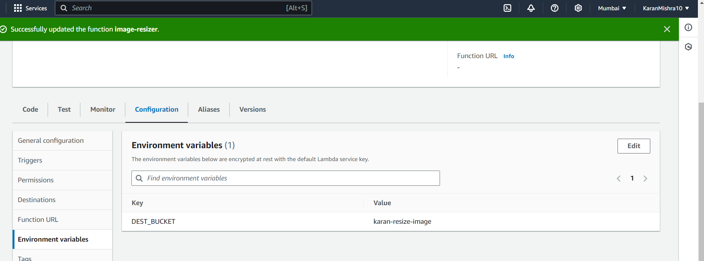
Instead of karan-resize-image put your bucket name where you want to store the resized image.
5.)Testing the Lambda function:-
1.)Go to the Test section of the Lambda function.
2.)Keep the rest of the configurations default and just change the template to S3-Put .
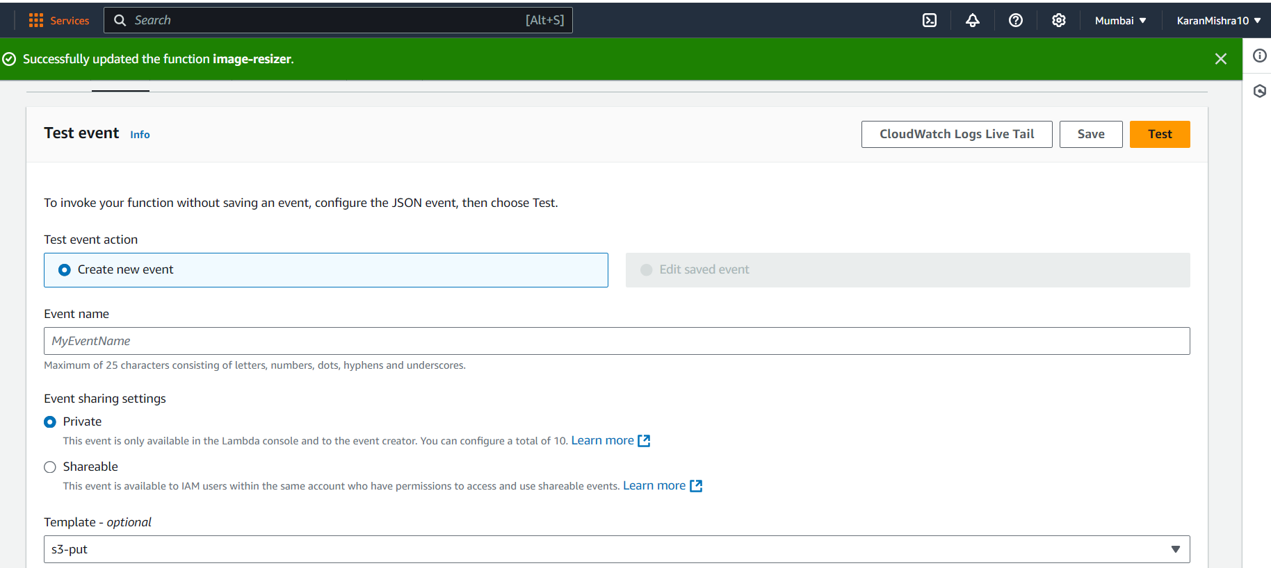
3.)In the Event JSON of the S3-Put Template change example-bucket (near name and arn in S3 Section of the JSON file )to your original image bucket and key(in object section) to the image which you had uploaded in Step 2 for testing. Here I have changed the example - bucket to karan-original-bucket and key to axolotl.jpg.
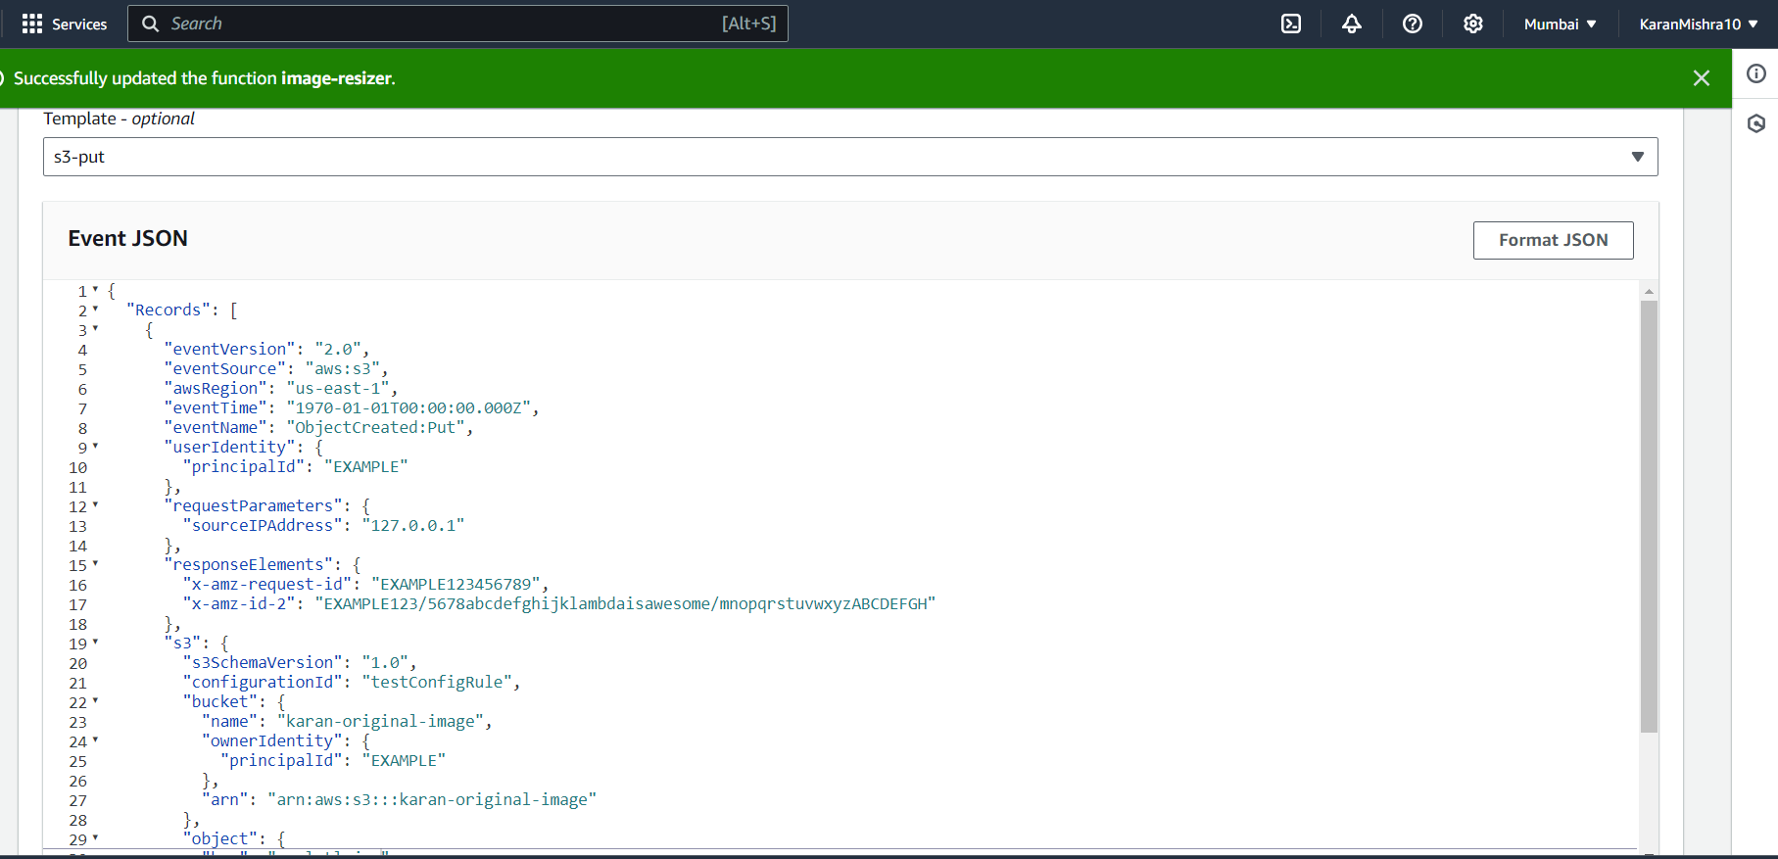
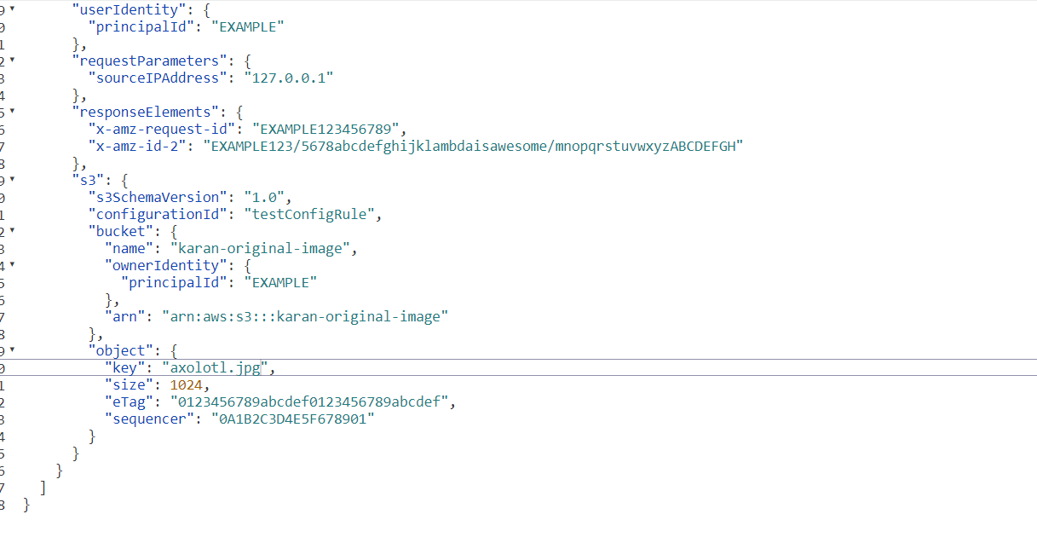

4.)Click on Test and see the output in the execution Logs. Here we got a status Code - 200 which means the function is running successfully.
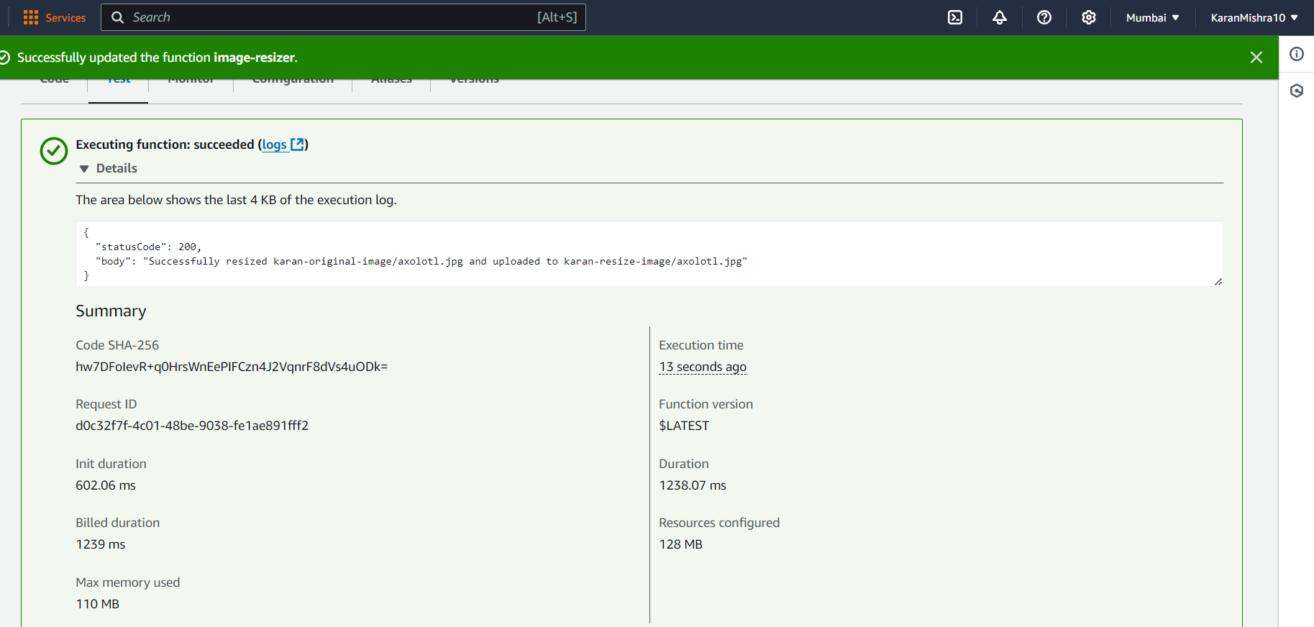
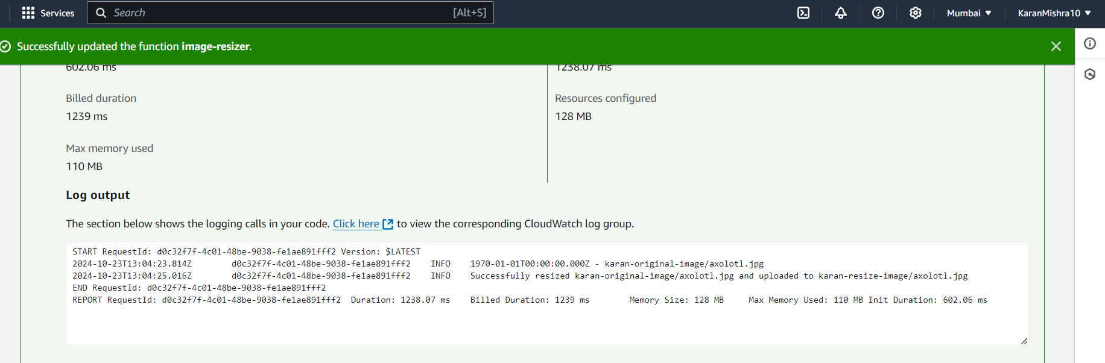
5.)Go to your resized image bucket to check the image which has been uploaded there by the execution of the function in the previous Step for testing.And also open the image in the browser to see the change in the dimensions of the image
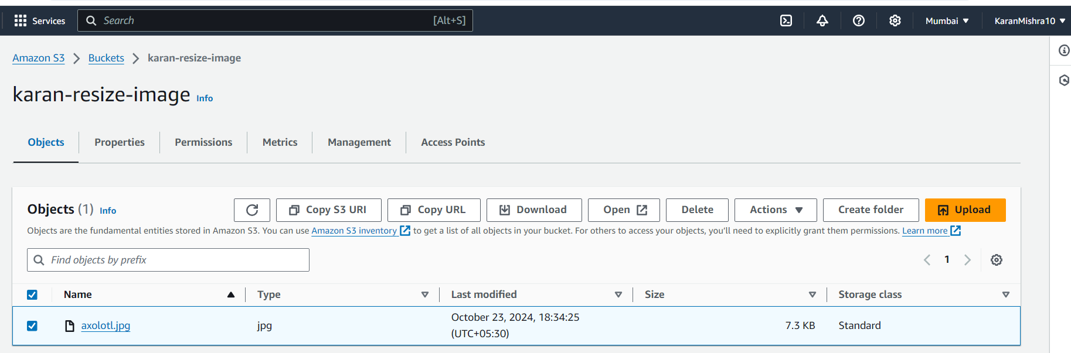
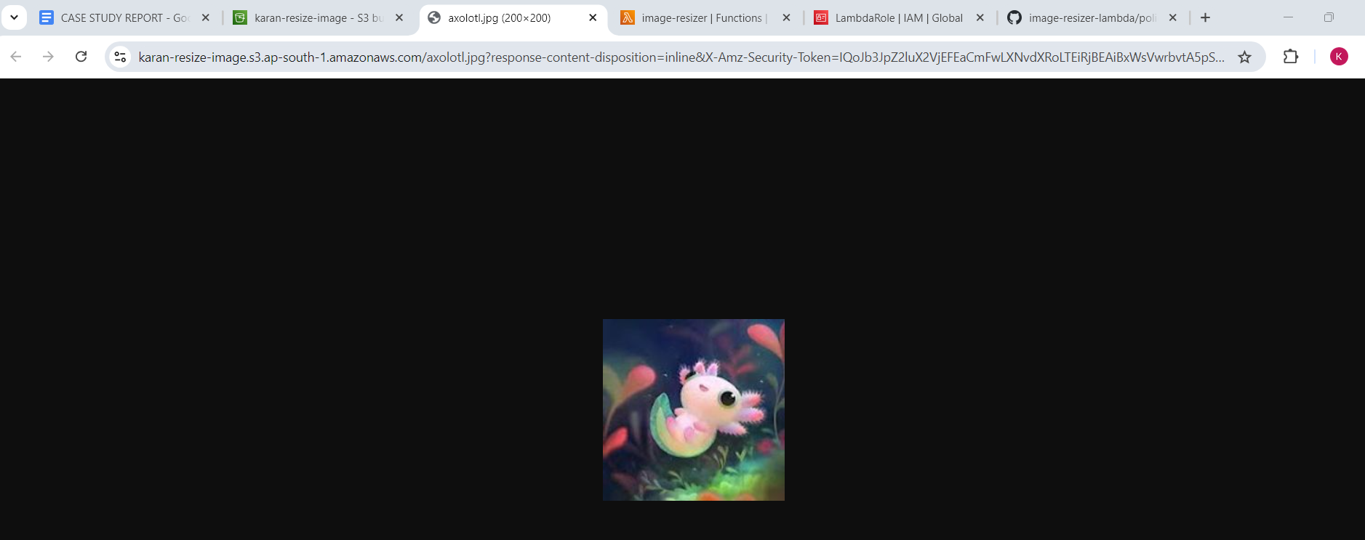
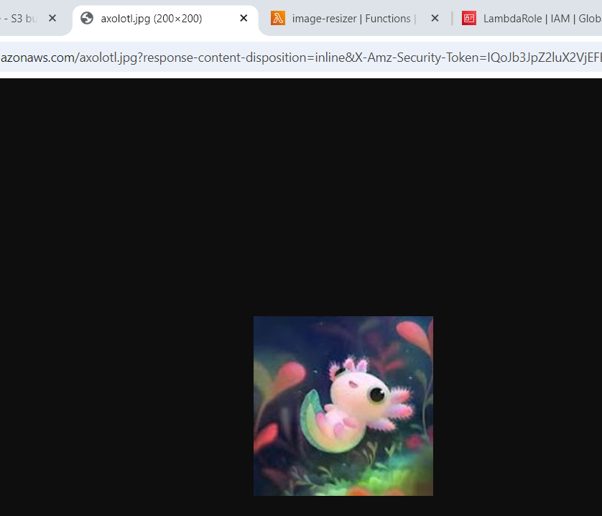
6.)Add Lambda Trigger:-
1.)Select Add Trigger on the Lambda Function Page.
2.)Select S3 in the Configuration and select your original image bucket(source bucket) so that whenever an Image is uploaded on that bucket the function is triggered and the Image is resized and stored on the resized image bucket.
3.)Keep Rest of the configurations Default.
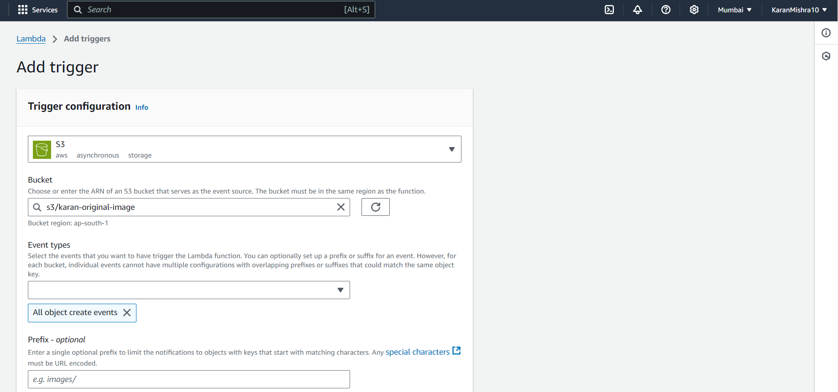
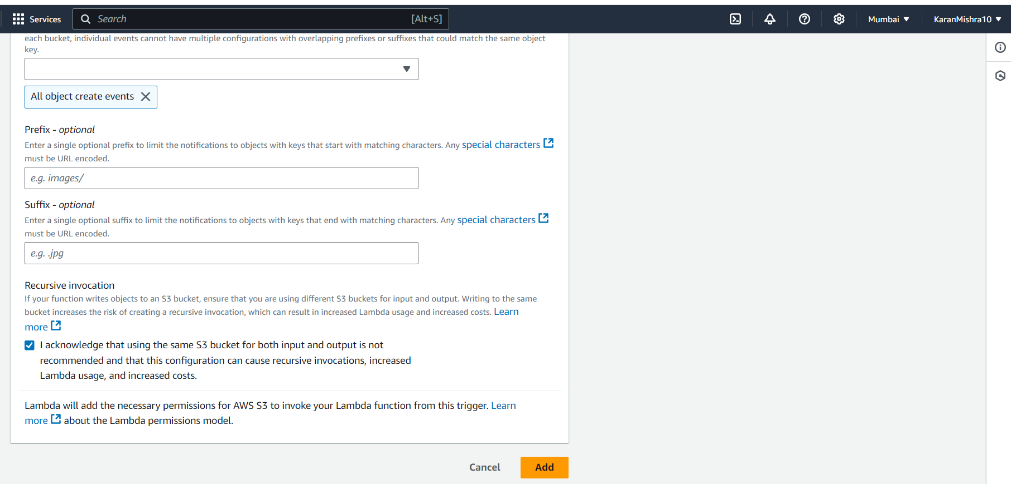
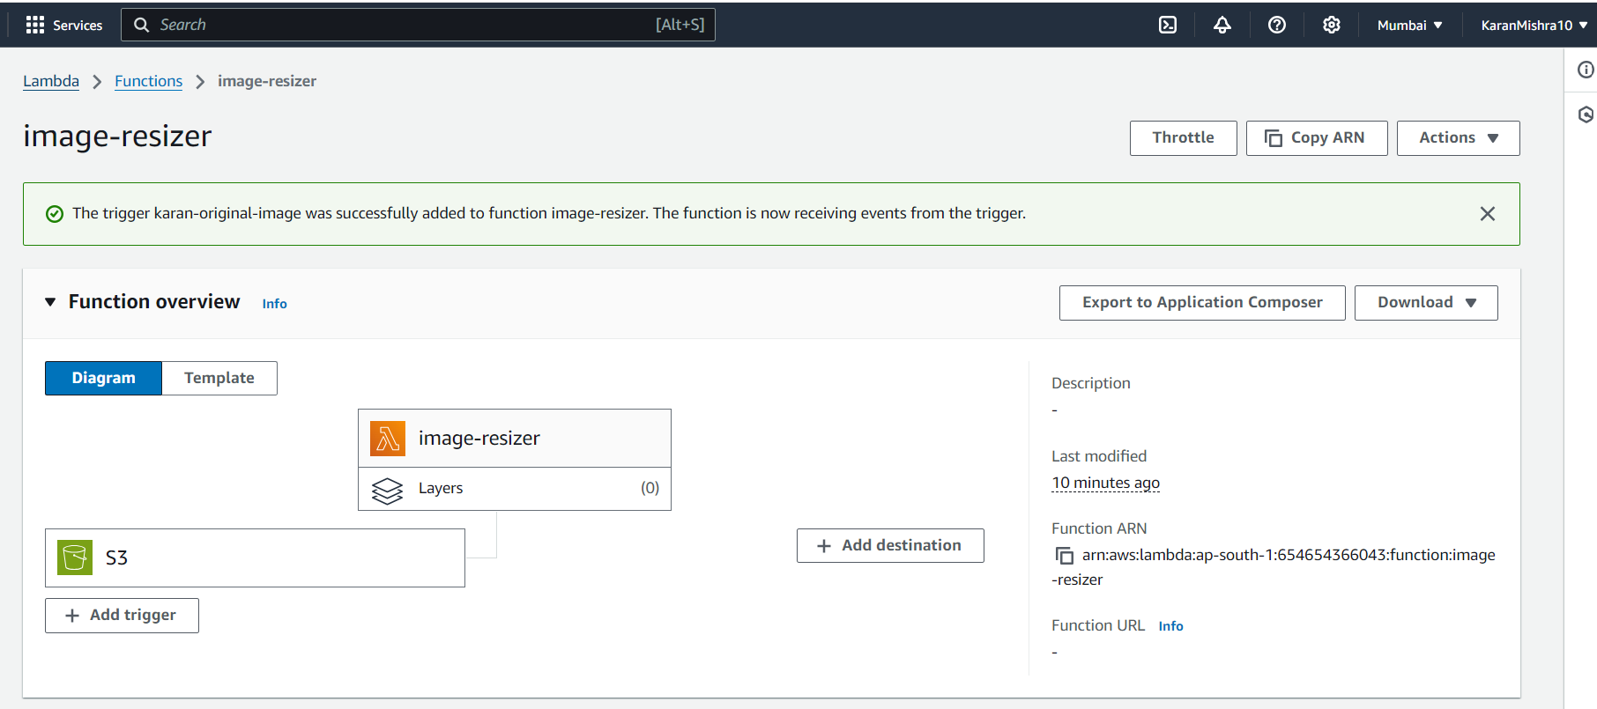
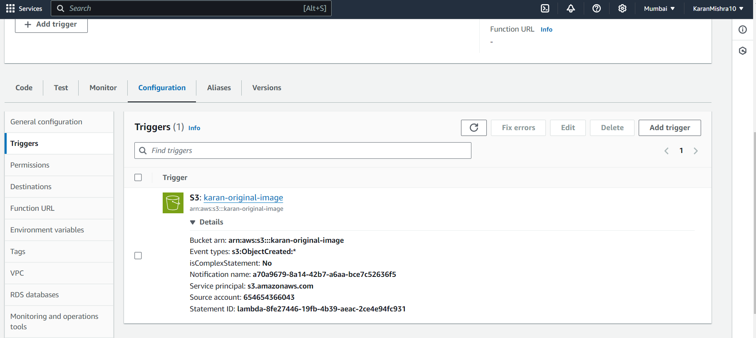

7.)Final Test:-
1.)Upload an image again in the original image bucket and open it in the browser and see its dimensions. Here I have uploaded an image stark.jpg for this .
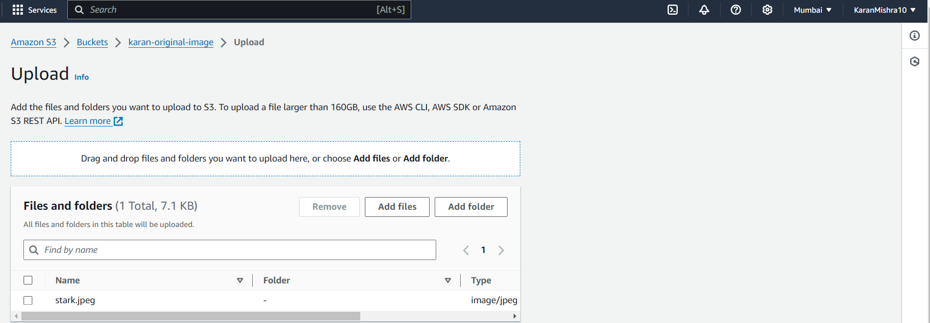
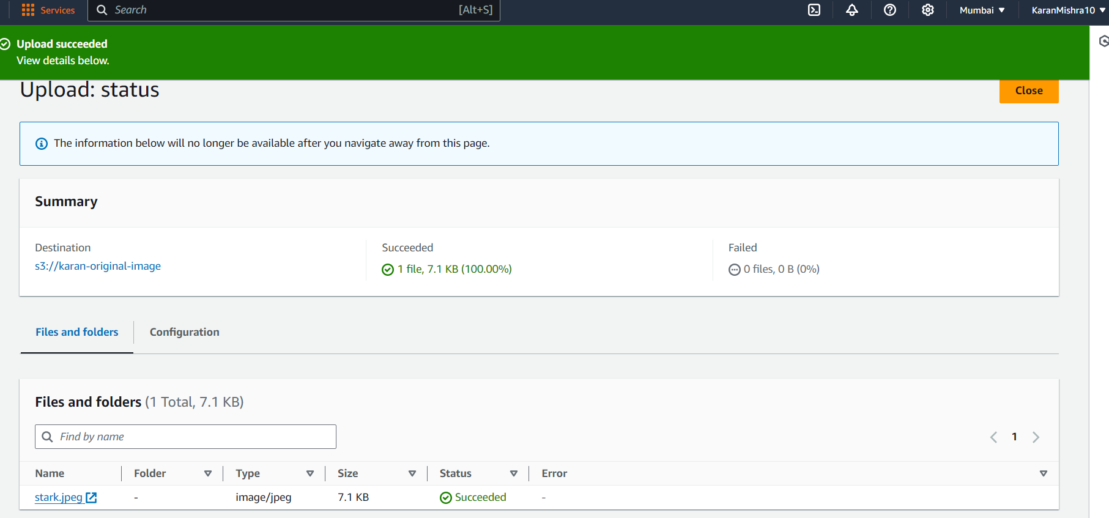
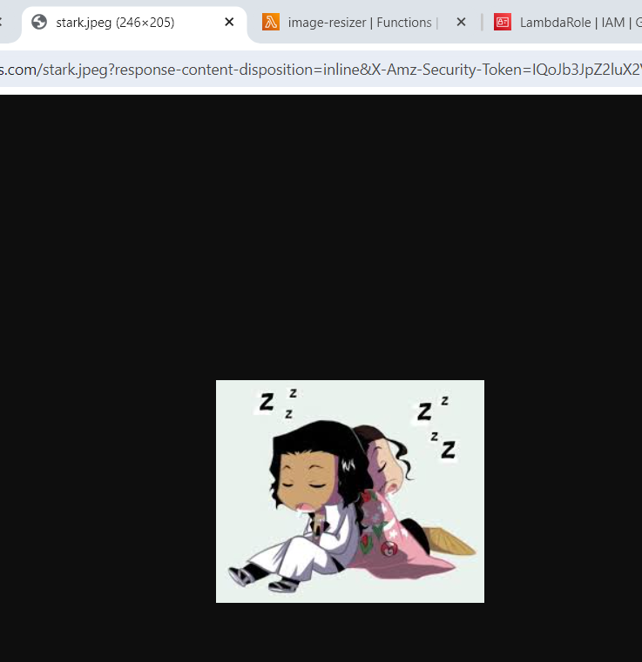
2.)Go to your resized image bucket and open the image in the browser to see changed Dimensions
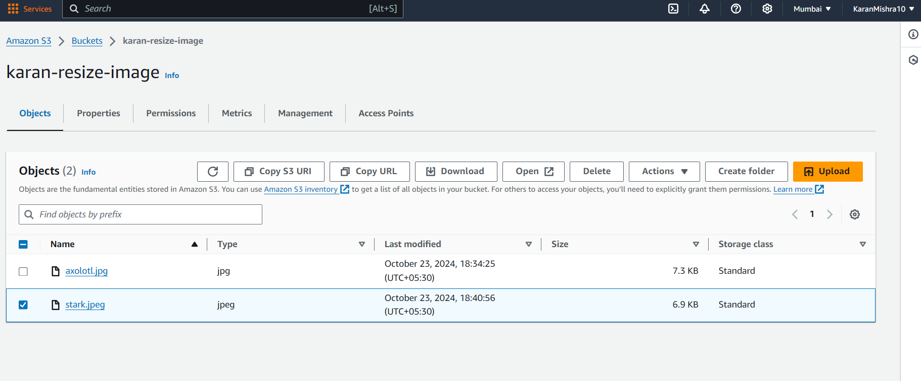
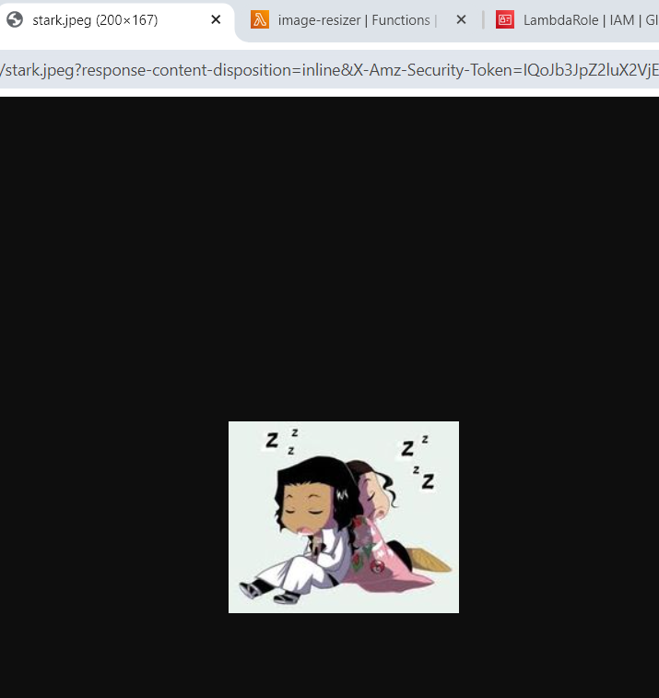
3.)Experiment successfully Done.
Conclusion:
By leveraging AWS Lambda and S3, an efficient and scalable solution for automatic image resizing is implemented. The Lambda function, developed in Node.js, ensures that each image uploaded to the source S3 bucket is resized and stored in the destination bucket without manual intervention. This approach enhances the image processing workflow, providing a cost-effective and automated system that can handle dynamic workloads.

